**INTRODUCTION**

**OVERVIEW**

This report discusses the result of the work done in development of “Optimizing Courier Delivery System” on JavaScript Platform. The project aims at the development of an application for solving the present difficulties faced by courier delivery agents by optimizing their courier delivery route according to the traffic conditions on the daily basis.

**BACKGROUND AND MOTIVATION**

Large courier companies use centralized computer systems to delegate delivery jobs to drivers.

If deliverymen carry multiple jobs concurrently these may lead to choose route, which may be sub optimal.

Therefore, with this system we tried to automate the courier delivery system, which can make decision that which delivery point it should reach first for feasible ways by taking list of address from all the nearest delivery points.

Therefore, with our application the system automates the delivery services that can make decisions as to which delivery point should be reached first for feasible ways by taking list of address from all the nearest delivery points.

**OBJECTIVE**

The final goal of the project is twofold.

1. Integration of google maps into the agent app, which helps the agent from the hassle of entering each and every location before delivering the courier quota for the day.
2. Automation of delivery services so that once the delivery agent enters the address of allotted packages, the system can make decisions as to which

package must be delivered first based on the nearest delivery points, traffic conditions and time taken.

**METHODOLOGY**

To implement the above goals, the following methodology needs to be followed:

1. Specifying the application and various components of the architecture.
2. Specifying the bindings between the various modules and JavaScript packages.
3. Specifying the server ports between the modules.
4. Analysis: Extracting the required data for analysis and then doing the analysis.

**ANALYSIS**

On the basis of analysis and literature survey regarding the present difficulties faced by the courier delivery executives, we decided to make this project as our mini project to help facilitate smooth delivery of the packages without any hassle for the delivery executives.

We made this possible by first integrating google maps into our application so that the delivery executive need not open the google map every now and then to check which route needs to be taken to reach sooner to the destination.

Secondly, once the delivery executive pin points all the locations of which he has to deliver the package for the day, our Google API automates the delivery services that can make decisions as to which delivery has to be made first by taking feasible route among all the available routes by taking list of address from all the nearest delivery points.

**REQUIREMENT ANALYSIS**:

**SOFTWARE REQUIREMENTS**:

Operating System: Windows 10 / Ubuntu

Front end: React.js v16.x, Bootstrap v4.2.1, HTML5 & CSS

Back end: Node.js v11.8.0

Database: MongoDB v4.0.1

**HARDWARE REQUIREMENTS:**

RAM: 8GB and above

Hard disk: 120GB and above

Processor: Intel i3 and above

**FUNCTIONAL REQUIREMENTS**:

1. Admin Login and Logout: This module enables the admin to have control over the packages to be delivered and active agents available to deliver the same.
2. Agent Login and Logout: This module enables the agent to know which packages are allotted to them for the day and where it has to be delivered.
3. Integrated Google Maps: Using Google Maps API, we have integrated the same in our application to help the agents deliver the package without any hassle.
4. Automate delivery routes: With this algorithm, we can automate the courier delivery that can make decisions as to which delivery point needs to be reached first by feasible ways from all the nearest delivery points.

**NON-FUNCTIONAL REQUIREMENTS**:

1. Platform independence: The web application should responsive on both the popular operating system Android and iOS.
2. Performance: The application should be able to run on all versions of OS after a limit and should consume less power. The web application should not crash at any condition.
3. Permissions and Authentication: The application should ask for user’s permissions to access GPS. No one apart from authorized agent/admin should be able to log in.
4. Live updates: The agent will get live updates when connected to internet.

**TOOLS AND TECHNOLOGIES**:

**APPLICATION DEVELOPMENT TECHNOLOGIES**:

This application is built using MERN stack ie MongoDB, Express, React.js and Node.js.

MongoDB is an open-source database software which is NoSQL in architecture. It stores data as JSON document. It is fast, reliable and efficient.

Express is a web application framework for Node.js. It is designed for building web applications and APIs. It has been called the de facto standard server framework for Node.js.

React.js is a JavaScript library for building user interfaces. Facebook and a community of individual developers and companies maintain it. React can be used as a base in the development of single-page or mobile applications.

**INTEGRATION TOOLS**:

**GIT AND GITHUB**:

Git is a distributed version-control system for tracking changes in source code during software development. It is designed for coordinating work among programmers, but it can be used to track changes in any set of files. Its goals include speed, data integrity and support for distributed, non-linear workflows.

GitHub is a web based hoisting service for version control using Git. It is mostly used for computer code. It offers all of the distributed version control and source code management functionality of Git as adding its own features.

**DESIGN**

**OVERVIEW OF THE SYSTEM**

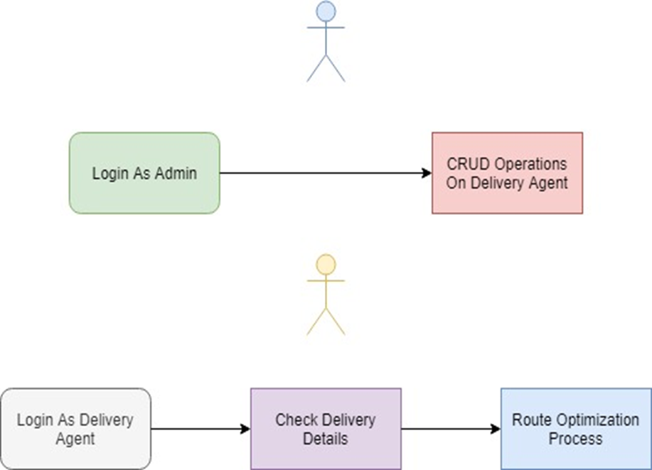

**ARCHITECTURE OF THE SYSTEM**

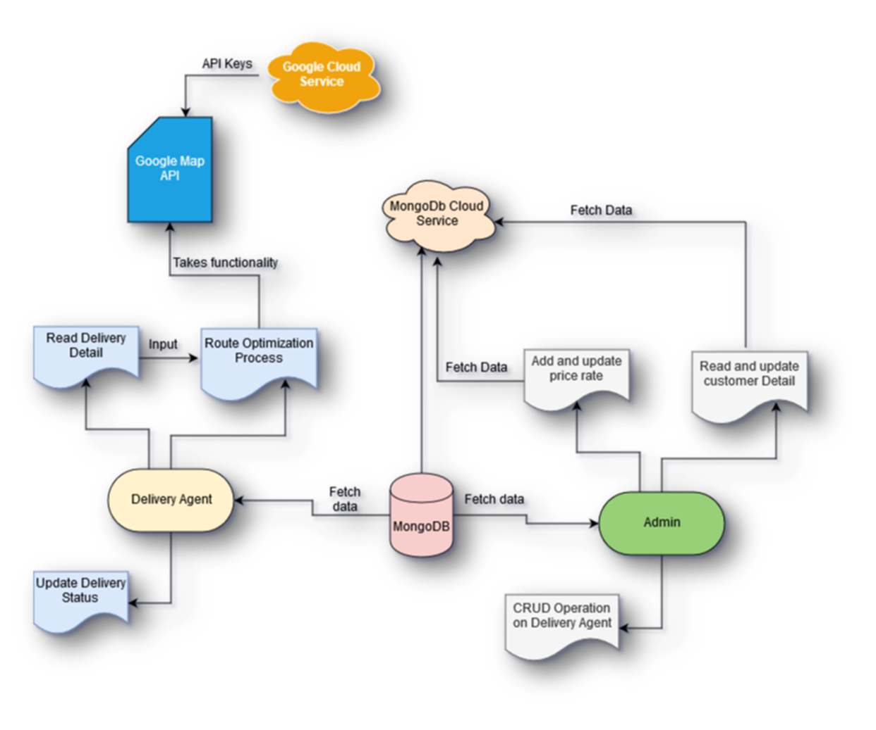

**USE CASE DIAGRAM**

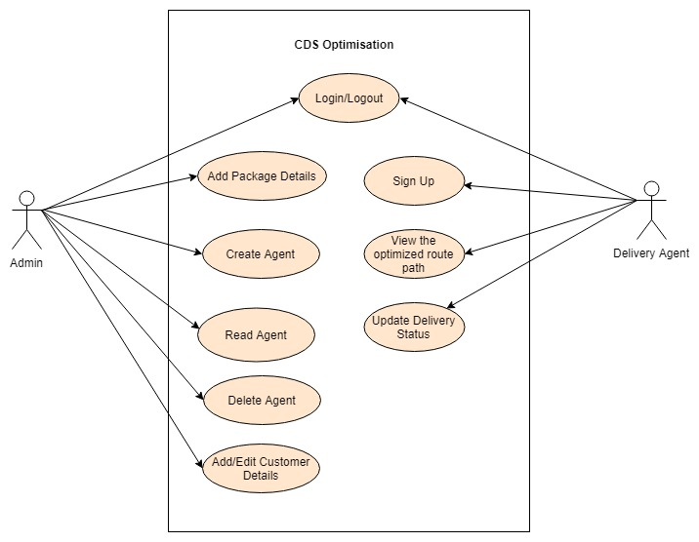

Our project consists of two folds:

1. Admin: Who has control over the application as to which all are the packages to be delivered to the destination and who all are the active agents and which packages are assigned to them for delivery.
2. Agent: Who can see which courier has been allotted to him for the day. Once he starts the map, it automates as to which courier has to be delivered and which feasible route is to be taken based on the traffic conditions and time taken.

**SCREEN SHOTS**

**LOGIN SCREEN**

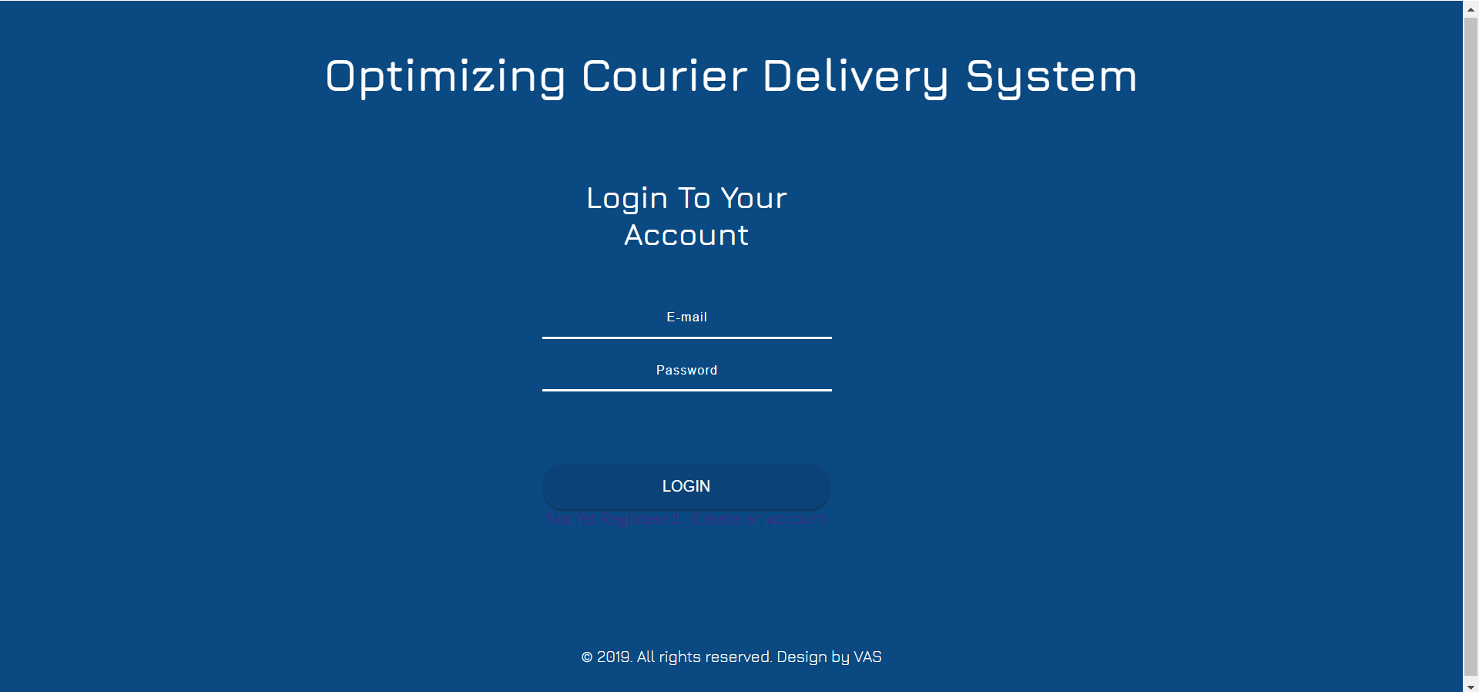

**REGISTRATION FORM**

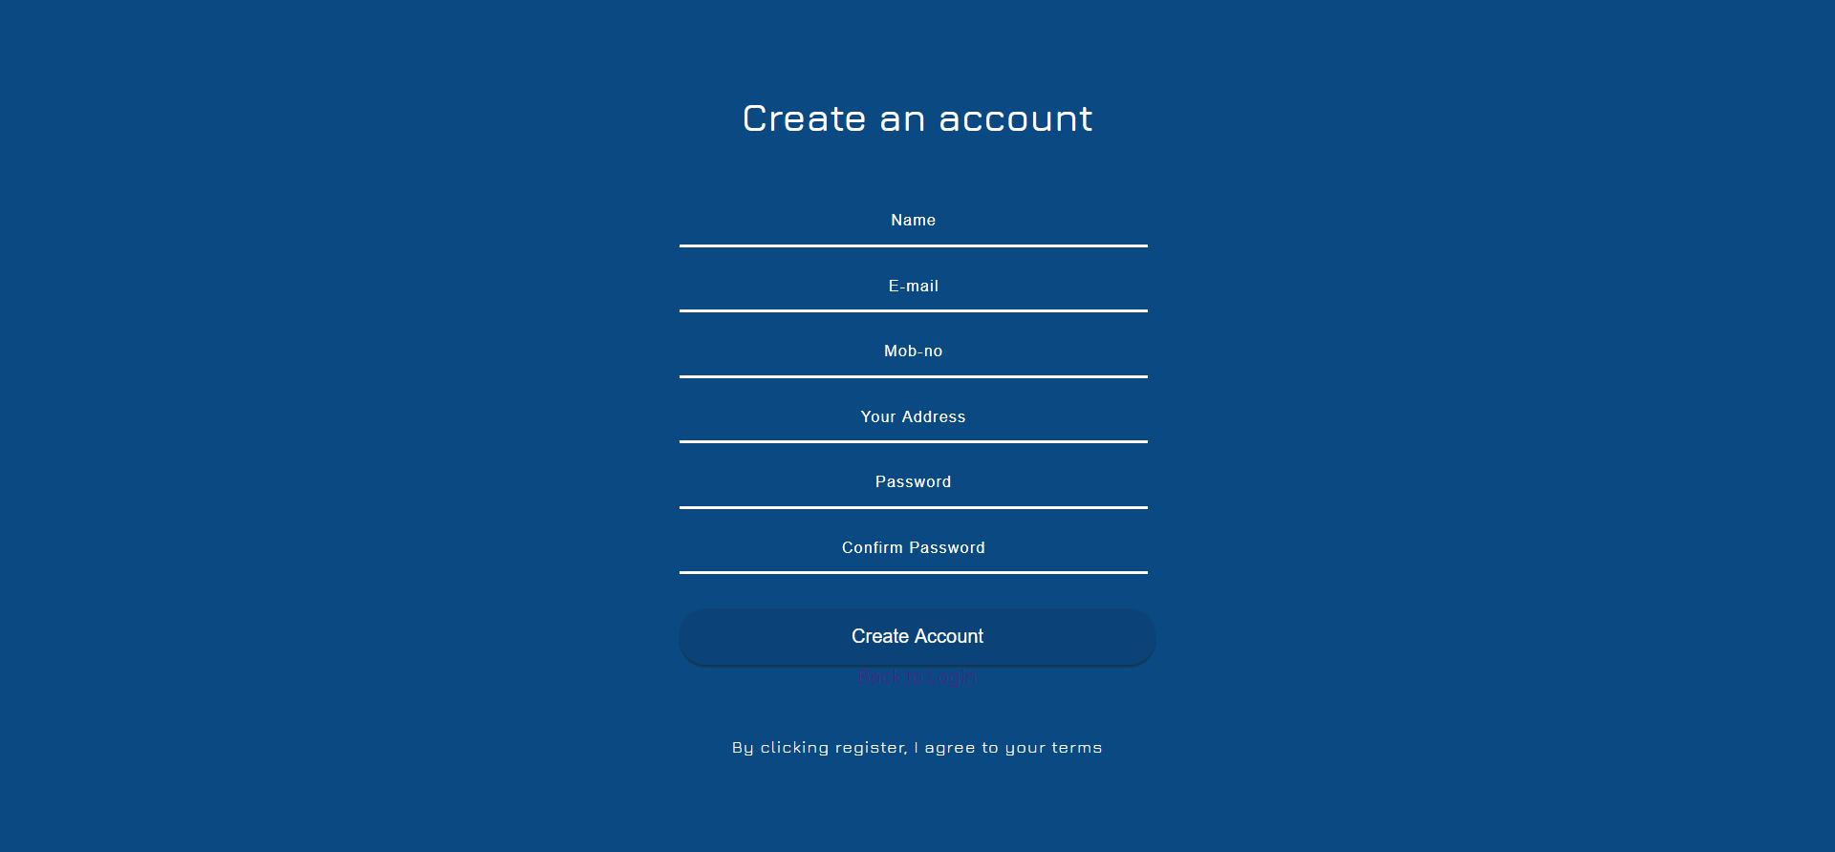

**ADMIN HOMEPAGE**

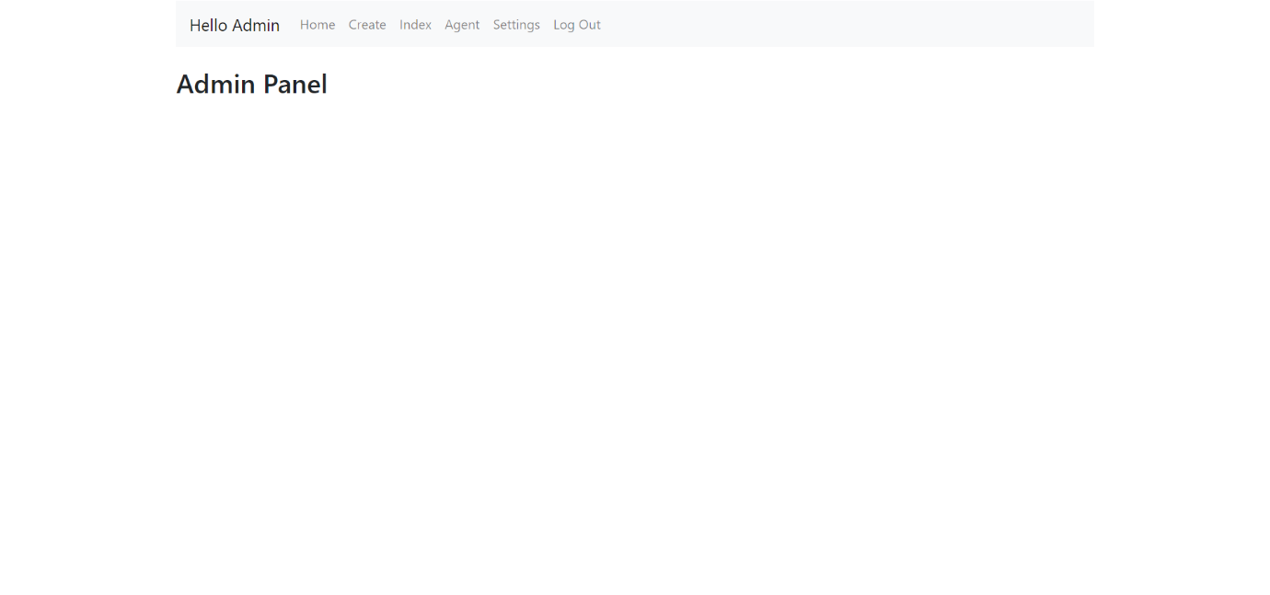

**PACKAGE CREATION**

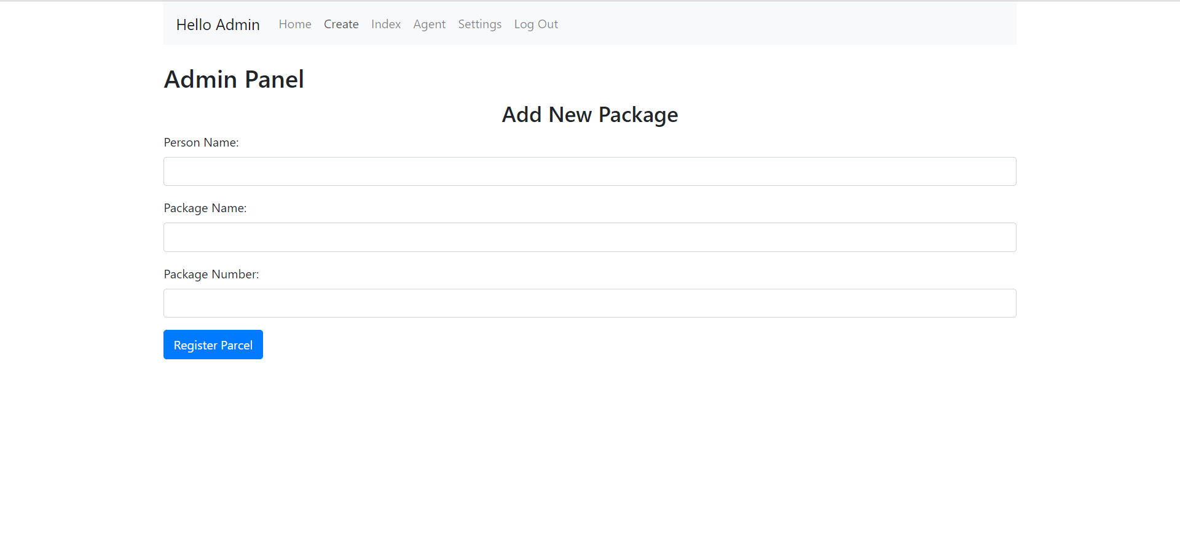

**PACKAGE LIST**

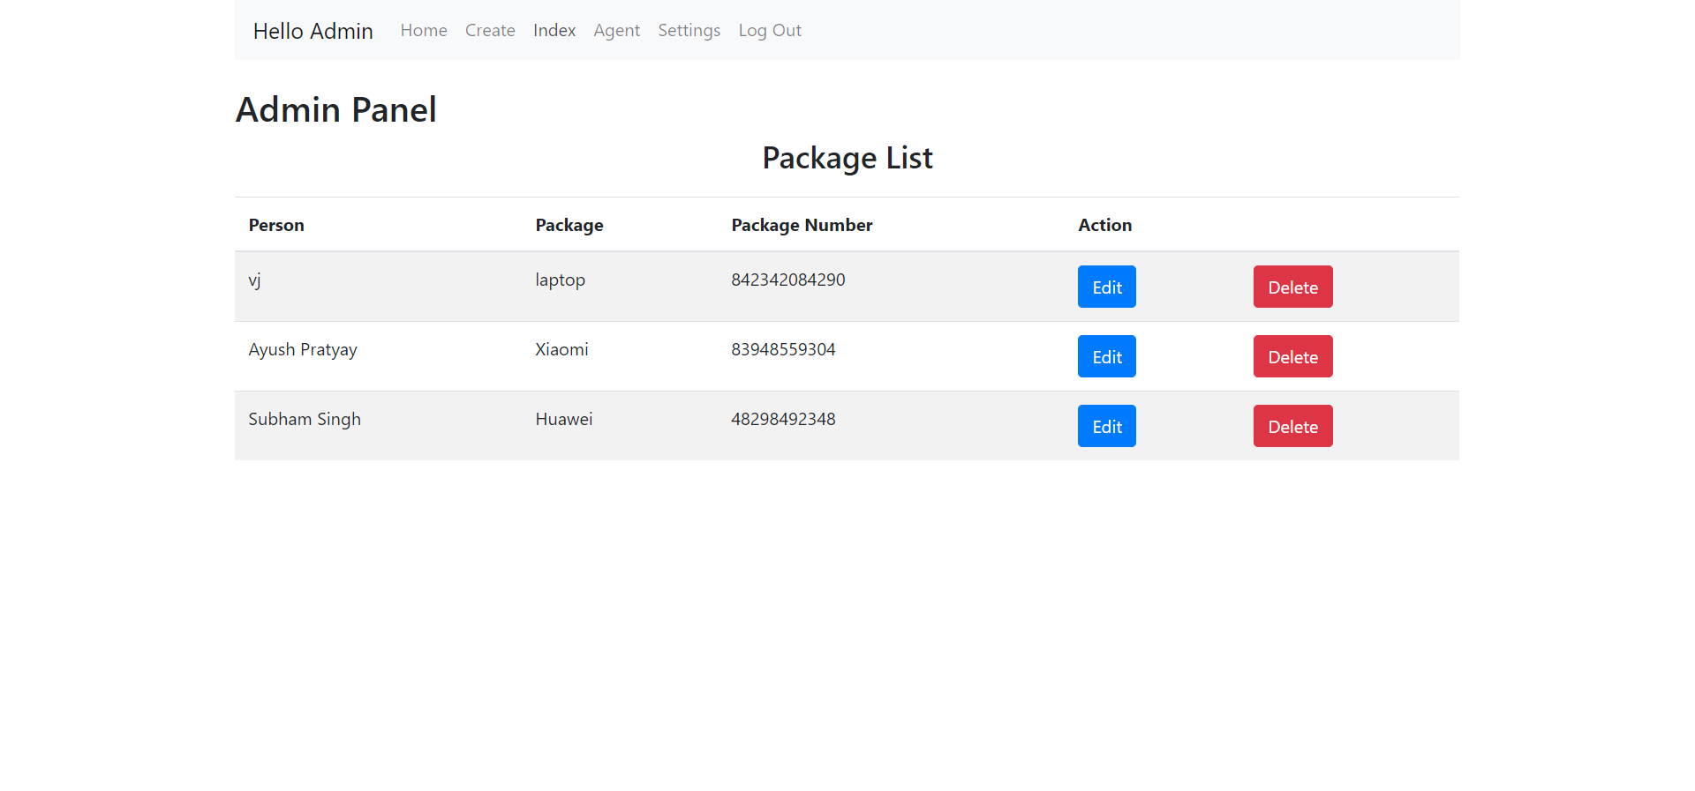

**ACTIVE AGENTS LIST**

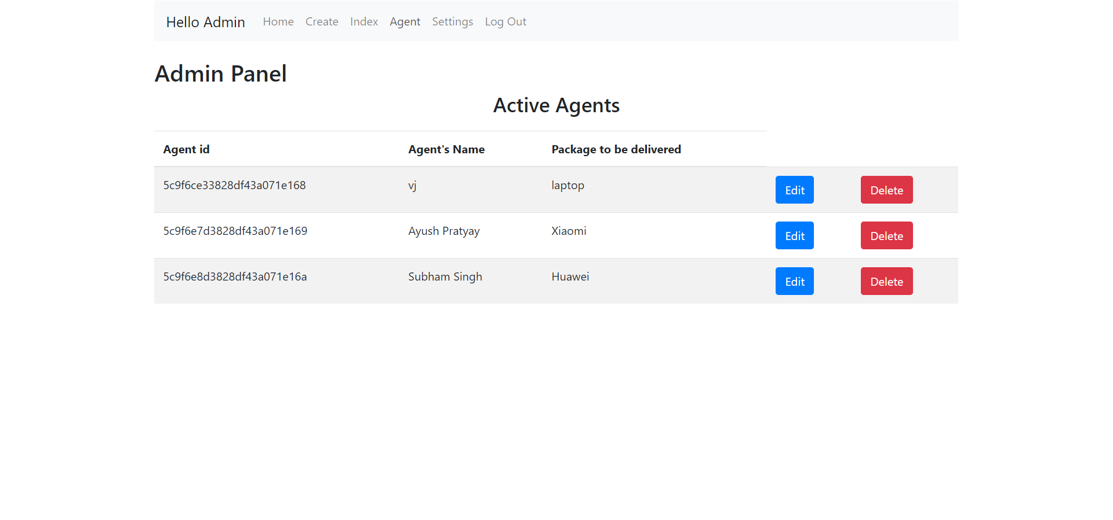

**DRIVER MODULE**

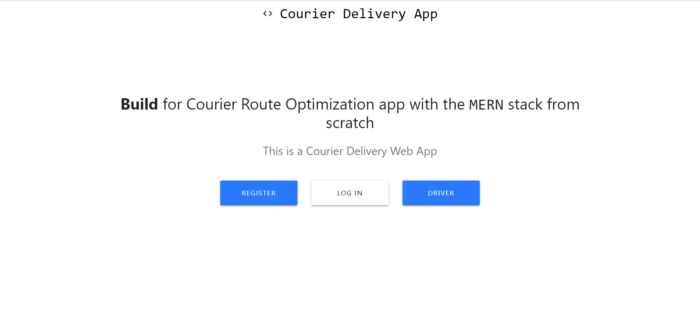

**DRIVER LOGIN**

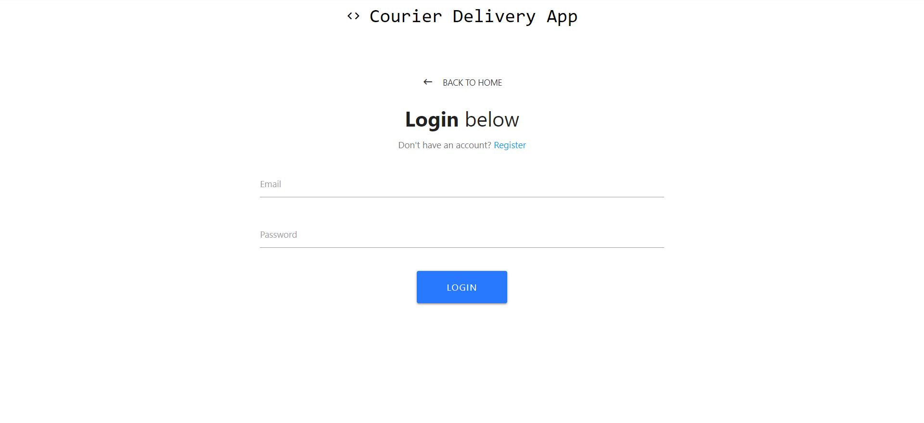

**REGISTRATION PAGE**

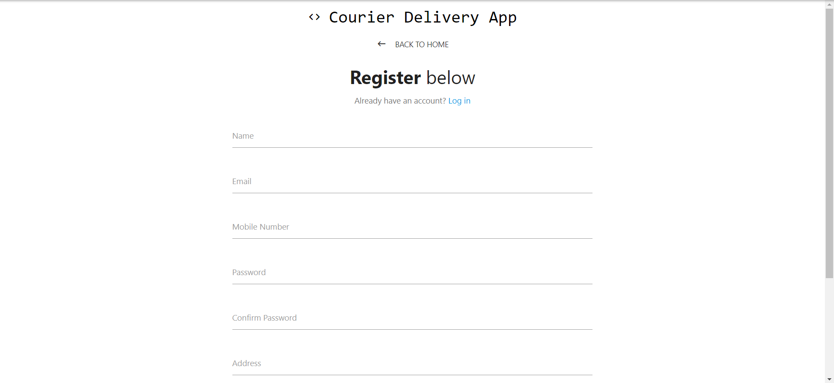

**MAP DEMO**

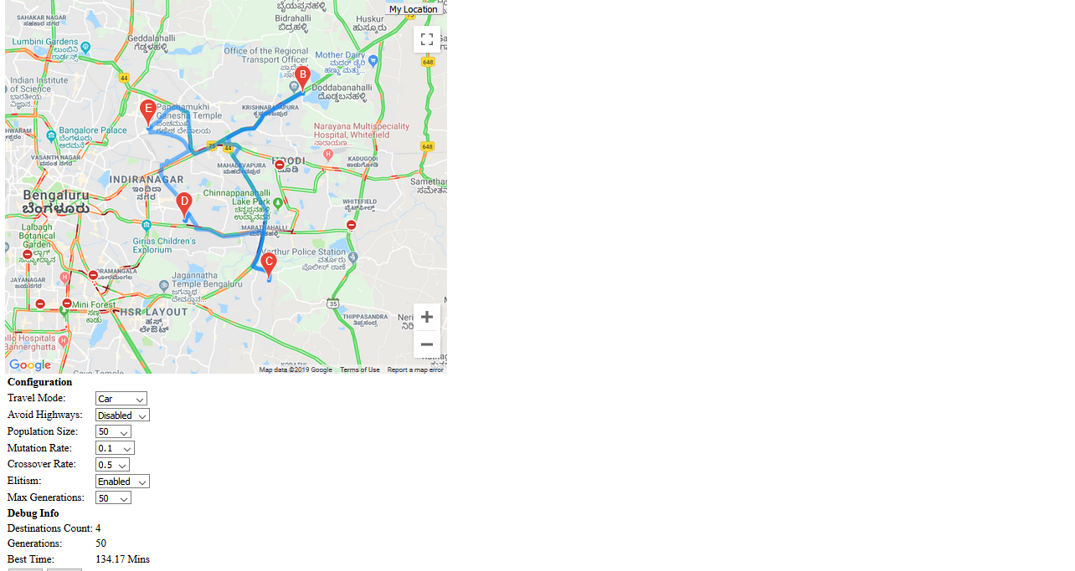

**TESTING**

|  |  |  |  |  |  |  |  |  |  |  |  |
| --- | --- | --- | --- | --- | --- | --- | --- | --- | --- | --- | --- |
| **Test Case ID** | | PES_001 | **Test Case Description** | | Test the Login Functionality in Admin Panel | | | | | | |
| **Created By** | | Vijaykumar R Pai | **Reviewed By** | | Deepthi S Narayan | | | **Version** | | 1 | |
|  |  |  |  |  |  |  |  | |  |  |  | |
| **QA Tester’s Log** | |  | | | |  |  | |  |  |  | |
|  |  |  |  |  |  |  |  | |  |  |  | |
| **Tester's Name** | | Vijaykumar R Pai | **Date Tested** | | 30-Mar-2019 | | | **Test Case (Pass/Fail/Not Executed)** | | Pass | |

|  |  |  |  |  |  |  |  |  |  |  |  |
| --- | --- | --- | --- | --- | --- | --- | --- | --- | --- | --- | --- |
| **S #** | **Prerequisites:** | | |  | **S #** | **Test Data** | | | | | |
| 1 | Access to Chrome Browser | | |  | 1 | E-mail = vijaykumarrpai@gmail.com | | | | | |
| 2 |  | | |  | 2 | Password = 12345678 | | | | | |
| 3 |  | | |  | 3 |  | | | | | |
| 4 |  | | |  | 4 |  | | | | | |
|  |  |  |  |  |  |  | |  | | |  |
| **Test Scenario** | Verify on entering valid email and password, the admin can login | | | | | |  | |  |  | |
|  |  |  |  |  |  |  | |  | | |  |
| **Step #** | **Step Details** | | **Expected Results** | | **Actual Results** | | | | | | **Pass / Fail / Not executed / Suspended** |
|
| 1 | Navigate to localhost:3000 | | Admin login page should open | | Admin login page is loaded | | | | | | Pass |
| 2 | Enter E-mail & Password | | Credentials can be entered | | Credentials are entered | | | | | | Pass |
| 3 | Click Login | | Admin is logged in | | Admin logged in successfully | | | | | | Pass |

|  |  |  |  |  |  |  |  |  |  |  |  |
| --- | --- | --- | --- | --- | --- | --- | --- | --- | --- | --- | --- |
| **Test Case ID** | | PES_002 | **Test Case Description** | | Test the Registration form Functionality in Admin Panel | | | | | | |
| **Created By** | | Vijaykumar R Pai | **Reviewed By** | | Deepthi S Narayan | | | **Version** | | 1 | |
|  |  |  |  |  |  |  |  | |  |  |  | |
| **QA Tester’s Log** | |  | | | |  |  | |  |  |  | |
|  |  |  |  |  |  |  |  | |  |  |  | |
| **Tester's Name** | | Vijaykumar R Pai | **Date Tested** | | 30-Mar-2019 | | | **Test Case (Pass/Fail/Not Executed)** | | Pass | |

|  |  |  |  |  |  |  |  |  |  |  |  |
| --- | --- | --- | --- | --- | --- | --- | --- | --- | --- | --- | --- |
| **S #** | **Prerequisites:** | | |  | **S #** | **Test Data** | | | | | |
| 1 | Access to Chrome Browser | | |  | 1 | Name = Vijaykumar R Pai | | | | | |
| 2 |  | | |  | 2 | E-mail = [vijaykumarrpai@gmail.com](mailto:vijaykumarrpai@gmail.com) | | | | | |
| 3 |  | | |  | 3 | Mob-no = 7582455420 | | | | | |
| 4 |  | | |  | 4 | Your Address = Blore | | | | | |
|  |  | | |  | 5 | Password = 12345678 | | | | | |
|  |  | | |  | 6 | Confirm Password = 12345678 | | | | | |
|  |  |  |  |  |  |  | |  | | |  |
| **Test Scenario** | Verify on entering name, email, mob-no, address, password and confirm password, the person can register as admin | | | | | |  | |  |  | |
|  |  |  |  |  |  |  | |  | | |  |
| **Step #** | **Step Details** | | **Expected Results** | | **Actual Results** | | | | | | **Pass / Fail / Not executed / Suspended** |
|
| 1 | Navigate to localhost:3000 | | Admin login page should open and navigate to registration form | | Admin page loaded and on click navigated to registration page | | | | | | Pass |
| 2 | Enter name, email, mob-no, address, password and confirm password | | Credentials can be entered | | Credentials are entered | | | | | | Pass |
| 3 | Click Create account | | Admin account is created | | Account created successfully | | | | | | Pass |

|  |  |  |  |  |  |  |  |  |  |  |  |
| --- | --- | --- | --- | --- | --- | --- | --- | --- | --- | --- | --- |
| **Test Case ID** | | PES_003 | **Test Case Description** | | Test adding new package Functionality in Admin Panel | | | | | | |
| **Created By** | | Vijaykumar R Pai | **Reviewed By** | | Deepthi S Narayan | | | **Version** | | 1 | |
|  |  |  |  |  |  |  |  | |  |  |  | |
| **QA Tester’s Log** | |  | | | |  |  | |  |  |  | |
|  |  |  |  |  |  |  |  | |  |  |  | |
| **Tester's Name** | | Vijaykumar R Pai | **Date Tested** | | 30-Mar-2019 | | | **Test Case (Pass/Fail/Not Executed)** | | Pass | |

|  |  |  |  |  |  |  |  |  |  |  |  |
| --- | --- | --- | --- | --- | --- | --- | --- | --- | --- | --- | --- |
| **S #** | **Prerequisites:** | | |  | **S #** | **Test Data** | | | | | |
| 1 | Access to Chrome Browser | | |  | 1 | Person name = vj | | | | | |
| 2 |  | | |  | 2 | Package name = Laptop | | | | | |
| 3 |  | | |  | 3 | Package number = 5845098591 | | | | | |
|  |  |  |  |  |  |  | |  | | |  |
| **Test Scenario** | Verify on entering name, email, mob-no, address, password and confirm password, the person can register as admin | | | | | |  | |  |  | |
|  |  |  |  |  |  |  | |  | | |  |
| **Step #** | **Step Details** | | **Expected Results** | | **Actual Results** | | | | | | **Pass / Fail / Not executed / Suspended** |
|
| 1 | Navigate to localhost:3000 | | Admin login page should open | | Admin login page loaded | | | | | | Pass |
| 2 | Enter E-mail & Password | | Credentials can be entered | | Credentials are entered | | | | | | Pass |
| 3 | Click Login | | Admin is logged in | | Admin logged in successfully | | | | | | Pass |
| 4 | Navigate to create section | | Page is loaded | | Toggled to create section | | | | | | Pass |
| 5 | Enter person name, package name and package number | | Data is entered | | Required fields are entered | | | | | | Pass |
| 6 | Click Register Parcel | | Data is stored in DB | | Data stored successfully into DB | | | | | | Pass |

|  |  |  |  |  |  |  |  |  |  |  |  |
| --- | --- | --- | --- | --- | --- | --- | --- | --- | --- | --- | --- |
| **Test Case ID** | | PES_004 | **Test Case Description** | | Test adding Package list Functionality in Admin Panel | | | | | | |
| **Created By** | | Vijaykumar R Pai | **Reviewed By** | | Deepthi S Narayan | | | **Version** | | 1 | |
|  |  |  |  |  |  |  |  | |  |  |  | |
| **QA Tester’s Log** | |  | | | |  |  | |  |  |  | |
|  |  |  |  |  |  |  |  | |  |  |  | |
| **Tester's Name** | | Vijaykumar R Pai | **Date Tested** | | 30-Mar-2019 | | | **Test Case (Pass/Fail/Not Executed)** | | Pass | |

|  |  |  |  |  |  |  |  |  |  |  |  |
| --- | --- | --- | --- | --- | --- | --- | --- | --- | --- | --- | --- |
| **S #** | **Prerequisites:** | | |  | **S #** | **Test Data** | | | | | |
| 1 | Access to Chrome Browser | | |  | 1 | Person name = vj | | | | | |
| 2 |  | | |  | 2 | Package name = Laptop | | | | | |
| 3 |  | | |  | 3 | Package number = 5845098591 | | | | | |
|  |  |  |  |  |  |  | |  | | |  |
| **Test Scenario** | Verify on clicking the delete button in package list, the respective package is deleted. | | | | | |  | |  |  | |
|  |  |  |  |  |  |  | |  | | |  |
| **Step #** | **Step Details** | | **Expected Results** | | **Actual Results** | | | | | | **Pass / Fail / Not executed / Suspended** |
|
| 1 | Navigate to localhost:3000 | | Admin login page should open | | Admin login page loaded | | | | | | Pass |
| 2 | Enter E-mail & Password | | Credentials can be entered | | Credentials are entered | | | | | | Pass |
| 3 | Click Login | | Admin is logged in | | Admin logged in successfully | | | | | | Pass |
| 4 | Navigate to index section | | Page is loaded | | Page loaded successfully | | | | | | Pass |
| 5 | Click delete to remove a particular package | | Package is deleted | | Package deleted successfully | | | | | | Pass |

|  |  |  |  |  |  |  |  |  |  |  |  |
| --- | --- | --- | --- | --- | --- | --- | --- | --- | --- | --- | --- |
| **Test Case ID** | | PES_005 | **Test Case Description** | | Test Agent list Functionality in Admin Panel | | | | | | |
| **Created By** | | Vijaykumar R Pai | **Reviewed By** | | Deepthi S Narayan | | | **Version** | | 1 | |
|  |  |  |  |  |  |  |  | |  |  |  | |
| **QA Tester’s Log** | |  | | | |  |  | |  |  |  | |
|  |  |  |  |  |  |  |  | |  |  |  | |
| **Tester's Name** | | Vijaykumar R Pai | **Date Tested** | | 30-Mar-2019 | | | **Test Case (Pass/Fail/Not Executed)** | | Pass | |

|  |  |  |  |  |  |  |  |  |  |  |  |
| --- | --- | --- | --- | --- | --- | --- | --- | --- | --- | --- | --- |
| **S #** | **Prerequisites:** | | |  | **S #** | **Test Data** | | | | | |
| 1 | Access to Chrome Browser | | |  | 1 | Person name = vj | | | | | |
| 2 |  | | |  | 2 | Package name = Laptop | | | | | |
| 3 |  | | |  | 3 | Package number = 5845098591 | | | | | |
|  |  |  |  |  |  |  | |  | | |  |
| **Test Scenario** | Verify on clicking the delete button in package list, the respective package is deleted. | | | | | |  | |  |  | |
|  |  |  |  |  |  |  | |  | | |  |
| **Step #** | **Step Details** | | **Expected Results** | | **Actual Results** | | | | | | **Pass / Fail / Not executed / Suspended** |
|
| 1 | Navigate to localhost:3000 | | Admin login page should open | | Admin login page loaded | | | | | | Pass |
| 2 | Enter E-mail & Password | | Credentials can be entered | | Credentials are entered | | | | | | Pass |
| 3 | Click Login | | Admin is logged in | | Admin logged in successfully | | | | | | Pass |
| 4 | Navigate to agent section | | Page is loaded | | Page loaded successfully | | | | | | Pass |
| 5 | Click delete to remove a particular agent | | Agent is deleted | | Agent deleted from DB successfully | | | | | | Pass |

|  |  |  |  |  |  |  |  |  |  |  |
| --- | --- | --- | --- | --- | --- | --- | --- | --- | --- | --- |
| **Test Case ID** | | PES_006 | **Test Case Description** | | Test the Login Functionality in Agent Panel | | | | | |
| **Created By** | | Ayush Pratyay | **Reviewed By** | | Deepthi S Narayan | | **Version** | | 2.1 | |
|  |  |  |  |  |  |  |  |  |  |  |
| **QA Tester’s Log** | |  | | | |  |  |  |  |  |
|  |  |  |  |  |  |  |  |  |  |  |
| **Tester's Name** | | Ayush Pratyay | **Date Tested** | | 31-03-2019 | | **Test Case (Pass/Fail/Not Executed)** | | Pass | |
|  |  |  |  |  |  |  |  |  |  |  |
| **S #** | **Prerequisites:** | | |  | **S #** | **Test Data** | | | | |
| 1 | Access to Chrome Browser | | |  | 1 | E-mail id = Ayush@gmail.com | | | | |
| 2 |  | | |  | 2 | Pass = arpit1 | | | | |
| 3 |  | | |  | 3 |  | | | | |
| 4 |  | | |  | 4 |  | | | | |
|  |  |  |  |  |  |  |  |  |  |  |
| **Test Scenario** | Verify on entering valid user id and password, the Agent can login | | | | | |  |  |  |  |
|  |  |  |  |  |  |  |  |  |  |  |
| **Step #** | **Step Details** | | **Expected Results** | | **Actual Results** | | | **Pass / Fail / Not executed / Suspended** | | |
|
| 1 | Navigate to <http://localhost:3000/> | | Agent login page should open | | Agent login page loaded | | | Pass | | |
| 2 | Enter E-mail id & Password | | Credentials can be entered | | Credentials are entered | | | Pass | | |
| 3 | Click Login | | Agent is logged in | | Agent logged in successfully | | | Pass | | |

|  |  |  |  |  |  |  |  |  |  |  |
| --- | --- | --- | --- | --- | --- | --- | --- | --- | --- | --- |
| **Test Case ID** | | PES_007 | **Test Case Description** | | Test the Registration Functionality in Agent Panel | | | | | |
| **Created By** | | Ayush Pratyay | **Reviewed By** | | Deepthi S Narayan | | **Version** | | 2.1 | |
|  |  |  |  |  |  |  |  |  |  |  |
| **QA Tester’s Log** | |  | | | |  |  |  |  |  |
|  |  |  |  |  |  |  |  |  |  |  |
| **Tester's Name** | | Ayush Pratyay | **Date Tested** | | 31-03-2019 | | **Test Case (Pass/Fail/Not Executed)** | | Pass | |
|  |  |  |  |  |  |  |  |  |  |  |
| **S #** | **Prerequisites:** | | |  | **S #** | **Test Data** | | | | |
| 1 | Access to Chrome Browser | | |  | 1 | Name = Ayush | | | | |
| 2 |  | | |  | 2 | Email Id = Ayush@gmail.com | | | | |
| 3 |  | | |  | 3 | Mob-no = 9876543210 | | | | |
| 4 |  | | |  | 4 | Address = Banshankari | | | | |
| 5 |  | | |  | 5 | Password = arpit1 | | | | |
| 6 |  | | |  | 6 | Conf password = arpit1 | | | | |
|  |  |  |  |  |  |  |  |  |  |  |
| **Test Scenario** | Verify on entering name, email, mob-no, address, password and confirm password, the person can register as agent | | | | | |  |  |  |  |
|  |  |  |  |  |  |  |  |  |  |  |
| **Step #** | **Step Details** | | **Expected Results** | | **Actual Results** | | | **Pass / Fail / Not executed / Suspended** | | |
|
| 1 | Navigate to <http://localhost:3000/> | | Agent registration page should open and navigate | | Agent login page loaded | | | Pass | | |
| 2 | Enter name, email, mob-no, address, password and confirm password | | Credentials can be entered | | Credentials are entered | | | Pass | | |
| 3 | Click Register | | Agent account is created | | Agent account created successfully | | | Pass | | |

|  |  |  |  |  |  |  |  |  |  |
| --- | --- | --- | --- | --- | --- | --- | --- | --- | --- |
| **Test Case ID** | | PES_008 | **Test Case Description** | | Test the Login Functionality in Driver module | | | | |
| **Created By** | | Ayush Pratyay | **Reviewed By** | | Deepthi S Narayan | | **Version** | | 2.1 |
|  |  |  |  |  |  |  |  |  |  |  |
| **QA Tester’s Log** | |  | | | |  |  |  |  |  |
|  |  |  |  |  |  |  |  |  |  |  |
| **Tester's Name** | | Ayush Pratyay | **Date Tested** | | 31-03-2019 | | **Test Case (Pass/Fail/Not Executed)** | | Pass |
|  |  |  |  |  |  |  |  |  |  |  |
| **S #** | **Prerequisites:** | | |  | **S #** | **Test Data** | | | |
| 1 | Access to Chrome Browser | | |  | 1 | E-mail id = Ayush@gmail.com | | | |
| 2 |  | | |  | 2 | Pass = arpit1 | | | |
| 3 |  | | |  | 3 |  | | | |
| 4 |  | | |  | 4 |  | | | |
|  |  |  |  |  |  |  |  |  |  |  |
| **Test Scenario** | Verify on entering valid userid and password, the Driver can login | | | | | |  |  |  |  |
|  |  |  |  |  |  |  |  |  |  |  |
| **Step #** | **Step Details** | | **Expected Results** | | **Actual Results** | | | **Pass / Fail / Not executed / Suspended** | |
|
| 1 | Navigate to <http://localhost:3000/> | | Driver login page should open | | Driver login page loaded | | | Pass | |
| 2 | Enter E-mail id & Password | | Credentials can be entered | | Credentials are entered | | | Pass | |
| 3 | Click Login | | Driver is logged in | | Driver logged in successfully | | | Pass | |

**CONCLUSION**

The objective of the project was to solve the difficulties faced by the courier delivery agents as to which courier has to be delivered first, which has been solved with our application as it shows feasible route once the delivery agent enters the location of the package to be delivered based on traffic conditions and time taken. Since our application is built with React JS, it is lightweight, responsive, loads faster once it will be deployed. Hence, the objective has been fulfilled and application shows optimized route for delivery of the courier.

**BIBLIOGRAPHY**

1. <https://medium.freecodecamp.org/the-react-handbook-b71c27b0a795>
2. <https://medium.com/javascript-in-plain-english/full-stack-mongodb-react-node-js-express-js-in-one-simple-app-6cc8ed6de274>
3. <https://appdividend.com/category/react-js/>
4. <https://www.npmjs.com/package/node-sms-send>
5. <https://stackoverflow.com/questions/42444909/which-is-the-best-place-to-learn-react-js>
6. Software Engineering – A Practitioner’s Approach, Roger S Pressman
7. React.js Essentials – Artemij Fedosejev